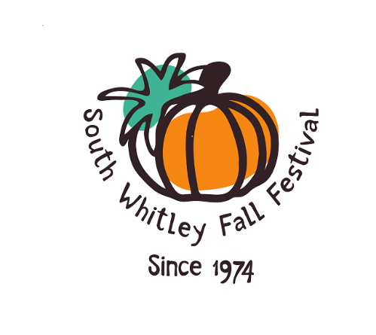”Celebrating 50 Years”
Fall Festival 2024 Parade Entry Form

Come help us celebrate our community and show us how you celebrate fall!
*The parade will be held on Saturday, September 28th at 2pm. Registration will begin at 1:00 pm at the Whitko High School parking lot.*
Please fill out the entry below to secure your spot.
Questions: Contact Nicki Venable (260) 418-6877
______________________________________________________________________________
2024 Festival Parade Entry Form

Entry Name:_______________________________________________________________
Contact Name:_______________________ Phone #:___________________________
Address:_____________________________ Email:_______________________
Please give a brief description about your entry in the space below. That will be given to our announcer for the parade.
*We agree not to hold liable the South Whitley Fall Festival Inc., the Town of South Whitley, nor anyone associated with this event for any damages or injury.

Signature:_______________________ Print:__________________________ Date:______________

Return your entry to: South Whitley Fall Festival, P.O.Box 472, South Whitley, IN 46787.

